**CA 2**

**CA_Ex1**

**package** ClassEx.CEx;

**import** org.openqa.selenium.By;

**import** org.openqa.selenium.WebDriver;

**import** org.openqa.selenium.chrome.ChromeDriver;

**import** org.openqa.selenium.chrome.ChromeOptions;

**import** org.testng.annotations.Test;

**import** io.github.bonigarcia.wdm.WebDriverManager;

**public** **class** CA_2 {

WebDriver driver;

@Test

**public** **void** f() **throws** InterruptedException{

ChromeOptions co=**new** ChromeOptions();

co.addArguments("--remote-allow-origins=*");

WebDriverManager.*chromedriver*().setup();

WebDriver driver=**new** ChromeDriver(co);

driver.get("https://www.trivago.in/");

driver.manage().window().maximize();

String currtitle=driver.getTitle();

System.***out***.println(currtitle);

String exptitle="trivago.in - Compare hotel prices worldwide";

**if**(currtitle.equals(exptitle)) {

System.***out***.println("Title get Matched");

}

**else** {

System.***out***.println("Title not get Matched");

}

Thread.*sleep*(3000);

driver.findElement(By.*xpath*("//*[@id=\"input-auto-complete\"]")).click();

Thread.*sleep*(3000);

driver.findElement(By.*xpath*("//*[@id=\"suggestion-list\"]/ul/li[1]/div/div")).click();

Thread.*sleep*(3000);

driver.findElement(By.*xpath*("//*[@id=\"__next\"]/div[1]/div[1]/section/div[2]/div[3]/div/div[2]/div/div/div/div[2]/div/div[1]/div[2]/button[24]/time")).click();

Thread.*sleep*(3000);

driver.findElement(By.*xpath*("//*[@id=\"__next\"]/div[1]/div[1]/section/div[2]/div[3]/div/div[2]/div/div/div/div[2]/div/div[1]/div[2]/button[26]/time")).click();

Thread.*sleep*(3000);

driver.findElement(By.*xpath*("//*[@id=\"__next\"]/div[1]/div[1]/section/div[2]/div[3]/div/div[2]/div/div/div[1]/div/div[1]/div[1]/div/button[2]")).click();

Thread.*sleep*(3000);

driver.findElement(By.*xpath*("//*[@id=\"__next\"]/div[1]/div[1]/section/div[2]/div[3]/div/div[2]/div/div/div[1]/div/div[1]/div[3]/div/button[2]")).click();

Thread.*sleep*(3000);

driver.findElement(By.*xpath*("/html/body/div[1]/div[1]/div[1]/section/div[2]/div[3]/div/div[2]/div/div/div[1]/div/div[2]/div[2]/input")).click();

Thread.*sleep*(3000);

driver.findElement(By.*xpath*("//*[@id=\"__next\"]/div[1]/div[1]/section/div[2]/div[3]/div/div[2]/div/div/div[2]/div/button[2]")).click();

}

}

**Output**

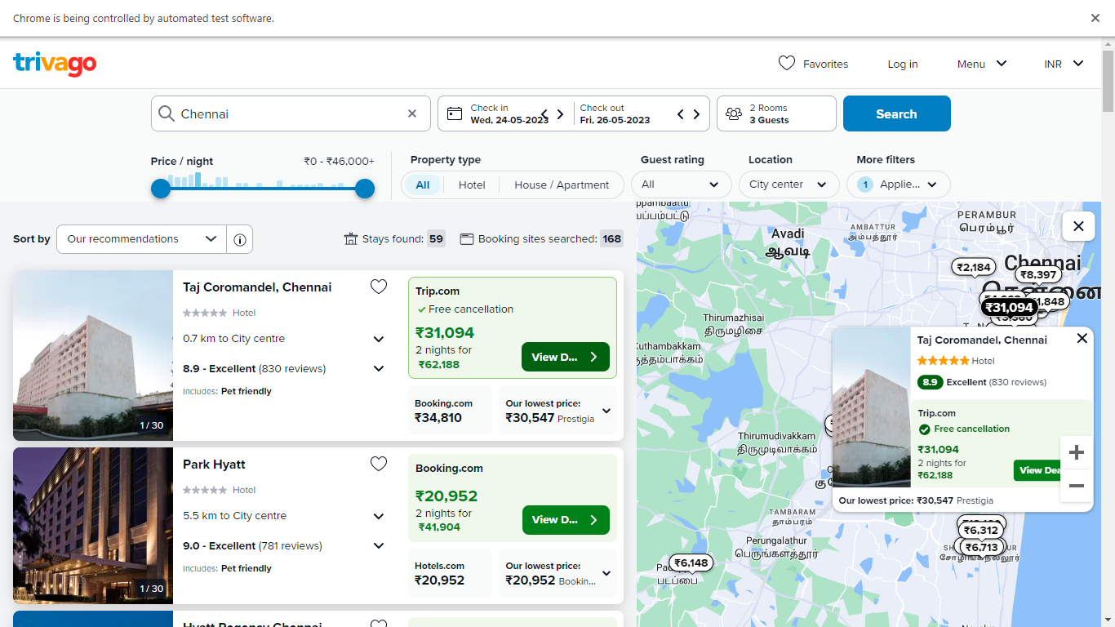

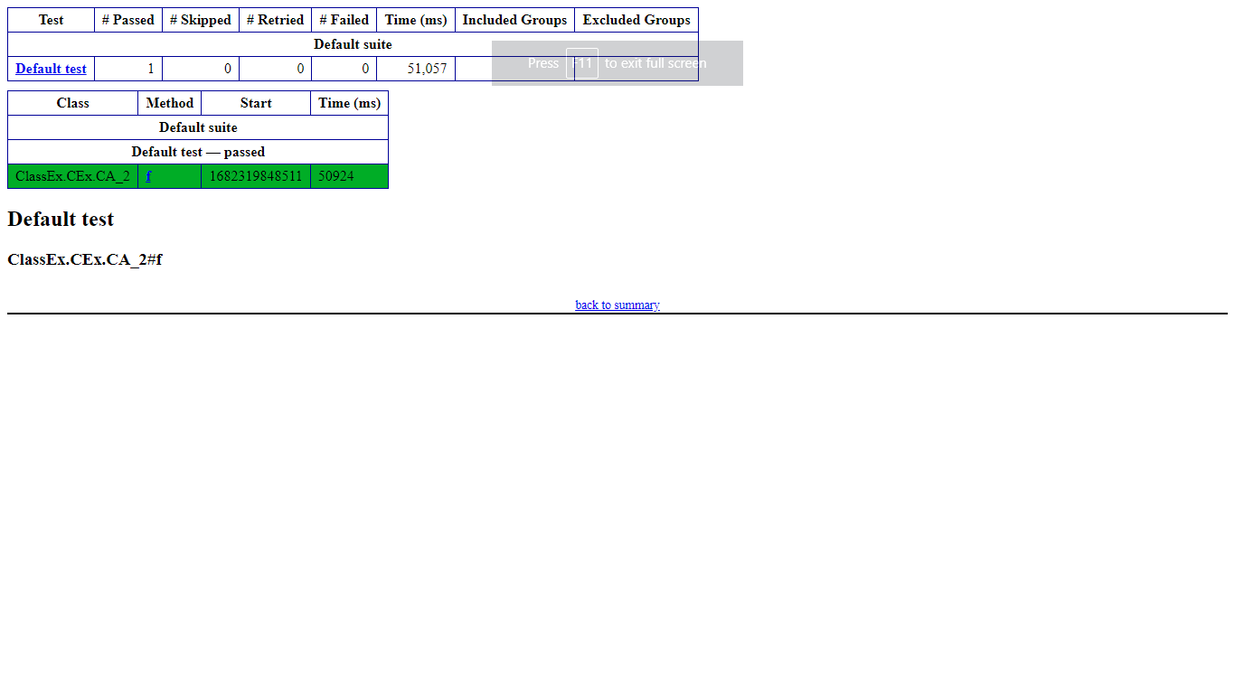

**CA_Ex2**

**package** ClassEx.CEx;

**import** org.testng.annotations.Test;

**import** io.github.bonigarcia.wdm.WebDriverManager;

**import** **static** org.junit.Assert.assertTrue;

**import** org.junit.AfterClass;

**import** org.junit.BeforeClass;

**import** org.openqa.selenium.By;

**import** org.openqa.selenium.WebDriver;

**import** org.openqa.selenium.WebElement;

**import** org.openqa.selenium.chrome.ChromeDriver;

**import** org.openqa.selenium.chrome.ChromeOptions;

**public** **class** CA_2{

WebDriver driver;

@BeforeClass

**public** **void** setup() {

WebDriverManager.chromedriver().setup();

ChromeOptions co=**new** ChromeOptions();

co.addArguments("--remote-allow-origins=*");

driver=**new** ChromeDriver(co);

driver.get("https://www.trivago.in/");

driver.manage().window().maximize();

}

@AfterClass

**public** **void** teardown() {

driver.quit();

}

@Test

**public** **void** testSortingByPriceAndRecommendations() {

WebElement sortDropdown = driver.findElement(By.cssSelector(".df_overlay_container [data-qa='sort-dropdown']"));

sortDropdown.click();

WebElement priceAndRecOption = driver.findElement(By.cssSelector("[data-qa='sort-option'][data-option-id='2']"));

priceAndRecOption.click();

WebElement hotelList = driver.findElement(By.cssSelector("[data-qa='itemlist-section']"));

WebElement firstHotel = hotelList.findElement(By.cssSelector("[data-qa='item'][data-index='0']"));

WebElement hotelName = firstHotel.findElement(By.cssSelector("[data-qa='item-name']"));

WebElement hotelPrice = firstHotel.findElement(By.cssSelector("[data-qa='recommended-price']"));

System.out.println(hotelName.getText() + " - " + hotelPrice.getText());

assertTrue(hotelPrice.isDisplayed());

}

@Test

**public** **void** testSortingByPrice() {

WebElement sortDropdown = driver.findElement(By.cssSelector(".df_overlay_container [data-qa='sort-dropdown']"));

sortDropdown.click();

WebElement priceOption = driver.findElement(By.cssSelector("[data-qa='sort-option'][data-option-id='1']"));

priceOption.click();

WebElement hotelList = driver.findElement(By.cssSelector("[data-qa='itemlist-section']"));

WebElement firstHotel = hotelList.findElement(By.cssSelector("[data-qa='item'][data-index='0']"));

WebElement hotelName = firstHotel.findElement(By.cssSelector("[data-qa='item-name']"));

WebElement hotelPrice = firstHotel.findElement(By.cssSelector("[data-qa='recommended-price']"));

System.out.println(hotelName.getText() + " - " + hotelPrice.getText());

assertTrue(hotelPrice.isDisplayed());

}

@Test

**public** **void** testNumberOfStaysFound() {

WebElement hotelList = driver.findElement(By.cssSelector("[data-qa='itemlist-section']"));

**int** numberOfStays = hotelList.findElements(By.cssSelector("[data-qa='item']")).size();

System.out.println("Number of stays found: " + numberOfStays);

assertTrue(numberOfStays > 0);

}

@Test

**public** **void** testNumberOfBookingSitesSearched() {

WebElement bookingSitesDropdown = driver.findElement(By.cssSelector(".df_overlay_container [data-qa='booking-sites-dropdown']"));

bookingSitesDropdown.click();

**int** numberOfSites = driver.findElements(By.cssSelector(".df_overlay_container [data-qa='booking-site-item']")).size();

System.out.println("Number of booking sites searched: " + numberOfSites);

assertTrue(numberOfSites > 0);

}

}

**Output**

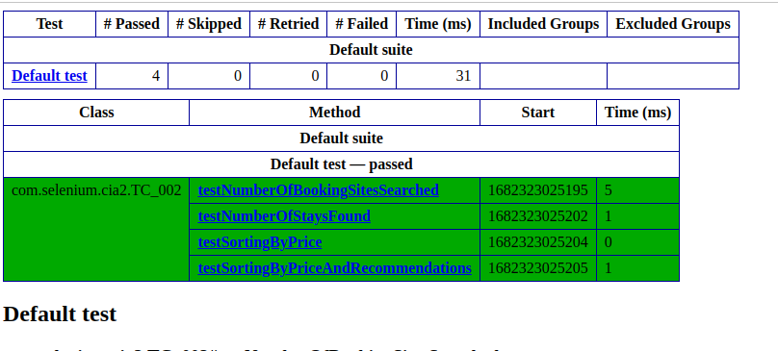

**CA_Ex3**

**package** ClassEx.CEx;

**import** java.util.List;

**import** org.openqa.selenium.By;

**import** org.openqa.selenium.WebDriver;

**import** org.openqa.selenium.WebElement;

**import** org.openqa.selenium.chrome.ChromeDriver;

**import** org.openqa.selenium.chrome.ChromeOptions;

**import** org.testng.annotations.Test;

**import** io.github.bonigarcia.wdm.WebDriverManager;

@Test

**public** **class** CA_2 {

WebDriver driver;

**public** **void** TC_003() {

WebDriverManager.chromedriver().setup();

ChromeOptions co=**new** ChromeOptions();

co.addArguments("--remote-allow-origins=*");

driver=**new** ChromeDriver(co);

driver.get("https://www.trivago.in/");

driver.manage().window().maximize();

List<WebElement> hotelNames = driver.findElements(By.xpath("//span[@data-qa='item-name']"));

**for** (**int** i = 0; i < 5; i++) {

System.out.println(hotelNames.get(i).getText());

}

WebElement viewDeal = driver.findElement(By.xpath("//span[@data-qa='recommended-price']"));

viewDeal.click();

String parentWindow = driver.getWindowHandle();

**for** (String childWindow : driver.getWindowHandles()) {

driver.switchTo().window(childWindow);

}

WebElement selectedHotelPrice = driver.findElement(By.xpath("//strong[@class='deal-price__amount']"));

System.out.println("Selected hotel price: " + selectedHotelPrice.getText());

WebElement selectRoom = driver.findElement(By.xpath("//button[contains(@class,'js-book-button')]"));

selectRoom.click();

WebElement firstName = driver.findElement(By.xpath("//input[@name='firstname']"));

firstName.sendKeys("Yuvan");

WebElement lastName = driver.findElement(By.xpath("//input[@name='lastname']"));

lastName.sendKeys("Sankar");

WebElement email = driver.findElement(By.xpath("//input[@name='email']"));

email.sendKeys("yuvan@gmail.com");

WebElement confirmEmail = driver.findElement(By.xpath("//input[@name='email_confirm']"));

confirmEmail.sendKeys("yuvan@gmail.com");

WebElement cancellationPolicy = driver.findElement(By.xpath("//h4[text()='Cancellation policy']/following-sibling::div/p"));

String cancellationPolicyText = cancellationPolicy.getText();

System.out.println("Check-in and Checkout dates: " + cancellationPolicyText);

driver.switchTo().window(parentWindow);

driver.close();

}

}

**Output**

